

Vivekanand Education Society’s Institute of Technology

NAME: NARENDER KESWANI

ROLL NO: 24

DIVISION: B

DEPARTMENT: MASTER OF COMPUTER APPLICATION (M.C.A)

SUBJECT: MCA14 - SOFTWARE PROJECT MANAGEMENT (SPM)

EXAM: CONTINOUS ASSESTMENT-3 (CA-3)

PROFESSOR: MONA DESHMUKH (MD)

DATE: 17/02/2022

**CA 3: Explore JIRA tool (you may download) and Design a Sprint and Backlog for any application of your choice. (Attach screen shot of it).**

**WHAT IS JIRA SOFTWARE?**

Jira Software is part of a family of products designed to help teams of all types manage work. Originally, Jira was designed as a bug and issue tracker. But today, Jira has evolved into a powerful work management tool for all kinds of use cases, from requirements and test case management to agile software development.

**JIRA FOR AGILE TEAMS:**

For teams who practice agile methodologies, Jira Software provides scrum and kanban boards out-of-the-box. Boards are task management hubs, where tasks are mapped to customizable workflows. Boards provide transparency across teamwork and visibility into the status of every work item. Time tracking capabilities and real-time performance reports (burn-up/down charts, sprint reports, velocity charts) enable teams to closely monitor their productivity over time.Jira Software supports any agile methodology for software development.

* Issue tracking
* Customizable workflows
* Estimation & work logging
* Progress reporting
* Scrum boards
* Kanban boards
* Project-level permissions
* Project backlogs
* Email notifications
* Roadmaps

### JIRA FOR PROJECT MANAGEMENT TEAMS:

### Jira Software can be configured to fit any type of project. Teams can start with a project template or create their own custom workflow. Jira issues, also known as tasks, track each piece of work that needs to pass through the workflow steps to completion. Customizable permissions enable admins to determine who can see and perform which actions. With all project information in place, reports can be generated to track progress, productivity, and ensure nothing slips. Jira Software can help your team manage a project from the start, through execution, to the wrap-up.

* Issue / Task management
* Roadmaps
* Report & Analytics
* Integrated mobile app
* Project backlogs
* Project & issue customization
* Granular user permissions
* Workflow customization

**JIRA FOR SOFTWARE DEVELOPMENT TEAMS:**

Jira Software provides planning and roadmap tools so teams can manage stakeholders, budgets, and feature requirements from day one. Jira integrates with a variety of CI/CD tools to facilitate transparency throughout the software development life cycle. When it’s ready to deploy, live production code status information is surfaced in the Jira issue. Integrated feature flagging tools allow teams to roll out new features gradually and safely. The DevOps template is designed for high-performing teams to save time and reduce errors by managing work from a variety of tools in one centralized place.

* Release planning
* Sprint planning
* CI/CD integrations
* Issue management
* Project Backlog
* Jira Service Management integration
* Feature flagging

**JIRA SOFTWARE FOR DEVOPS TEAMS:**

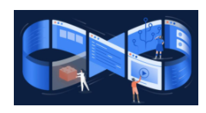DevOps is a set of practices that works to automate and integrate the processes between software development and IT teams, so they can build, test, and release software faster and more reliably. For teams practicing DevOps, Jira Software is the backbone of Atlassian’s open, integrated toolchain known as Open DevOps. Jira Software integrates with first- and third-party tools throughout the DevOps lifecycle, including code and version control tools like Bitbucket, GitHub, and Gitlab, documentation and knowledge management tools like Confluence, and monitoring and operating tools like Opsgenie. Jira Software also integrates with tools across a variety of categories to help DevOps teams ship better software, faster, with a focus on best practices including:

* Automation
* Testing
* Security
* Observability
* Feature Flagging
* Continuous Delivery and Deployment

**JIRA FOR PRODUCT MANAGEMENT TEAMS:**

In Jira Software, teams can build a roadmap that’s associated with each project. The roadmap enables teams to sketch out the longer-term view of their work as well as track and share progress for their roadmap. Add more detail to your roadmaps, surfacing dependencies and forecasts for when you might complete your work. Create a view highlighting ‘live’ roadmaps from multiple teams by embedding the Jira Software roadmap into Confluence.

* Project templates
* Project roadmap
* Roadmap progress tracking
* Reporting and metrics
* Advanced Roadmaps
* Dependency mapping
* Forecasts

**JIRA FOR TASK MANAGEMENT:**

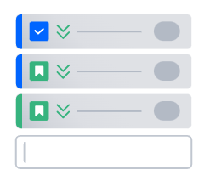Create tasks for yourself and members of your team to work on, complete with its details, due dates, and reminders. Utilize subtasks to breakdown larger items of work. Allow others to watch the task to track its progress and be notified when it’s completed. Create sub-tasks within the parent task to break down the unit of work into digestible pieces for various members of the team. View all tasks on the board to easily visualize each’s status.

* Email notifications
* Issue hierarchy
* Subtasks
* Task change log / history
* Custom fields
* Task linking / relationships
* Project linking

**JIRA FOR BUG TRACKING:**

Bugs are just a name for to-do's stemming from problems within the software a team is building. It is important for teams to view all the tasks and bugs in the backlog so they can prioritize big picture goals. Jira’s powerful workflow engine ensures that bugs are automatically assigned and prioritized once they are captured. Teams can then track a bug through to completion.

* Product / Issue backlog
* Customizable workflows
* Email notifications
* Task / bug linking
* Project level configuration

**Glossary of items**

Scrum board:

Scrum boards enable teams to manage their sprints and backlog.

Kanban board:

A kanban board allows teams to visualize the flow of work and limit work in progress.

Backlogs:

A backlog contains outstanding issues for a team to work on.

Epics, User Stories, Issues:

An epic represents a large body of work, which may require several sprints to complete. Multiple user stories comprise an epic. A Jira issue represents a single piece of work in a project.

Time Tracking:

Time tracking allows teams to record the amount of time they spend working on issues.

Custom workflows:

Teams can create custom workflows to drive the progression of issues on a scrum or kanban board.

Roadmaps:

Roadmaps create a visual representation of all the epics a team is working on, so teams can plan large pieces of work in advance.

Advanced search:

Advanced search uses Jira Query Language (JQL) to search for specific criteria in issues that can’t be done in quick or basic searches.

Permissions:

Utilize permissions to grant team members different levels of access and to lock down sensitive information.

**PROJECT DESCRIPTION:**

“**My Remote Desk: Remote Monitoring System”**

* **ABSTRACT:**
* As COVID - 19 increasing day by day, all the office work is shifted to the work from home. All organization have the employees and doing work from home. Now, it is difficult for the organizations to check or determine whether their employees are work productive or not. To overcome this problem, our system will help organization and to determine whether the employee is productive or not. The system includes basic components that continuously estimate the key behavior cues: app and website monitoring, screen shot monitoring, app and website time usage, attendance monitoring. By combining the continuous estimation components, we design higher level features to classify whether the user/employee is productive or not. Not only monitoring & tracking will be focus, the focus will be for work from home integrated platform which as features such as project management system, group meeting, etc.

**MODULES:**

* **App & Website tracking:** System will track the apps and websites which are used by the user/employee at the time of the work. System will create the logs and send logs to the organization panel.
* **Screen Shot Monitoring:** System will take screen shots of the employee desktop screen at the interval of 2-5 min and send all snapshots to the organization panel.
* **Automated Attendance Management System:** Taking the attendance of the user/employee whenever user starts the work and ends the work, sending those logs to the organization panel.
* **App & Website time tracking:** System will track and monitor the apps and website, how much user/employee has spent the time and sends logs to the organization panel.
* **Group Meeting:** Organization can create an group meeting for employee where they can meet and discuss about the project.
* **Project Management System:** Organization can create projects, tasks, assigned tasks to employee, create boards, etc.
* **Dashboard:** Organization and employee has the separate interactive dashboard where they can perform functions.

**1: CREATE FREE ACCOUNT ON THE** [**https://www.atlassian.com/software/jira/free**](https://www.atlassian.com/software/jira/free)

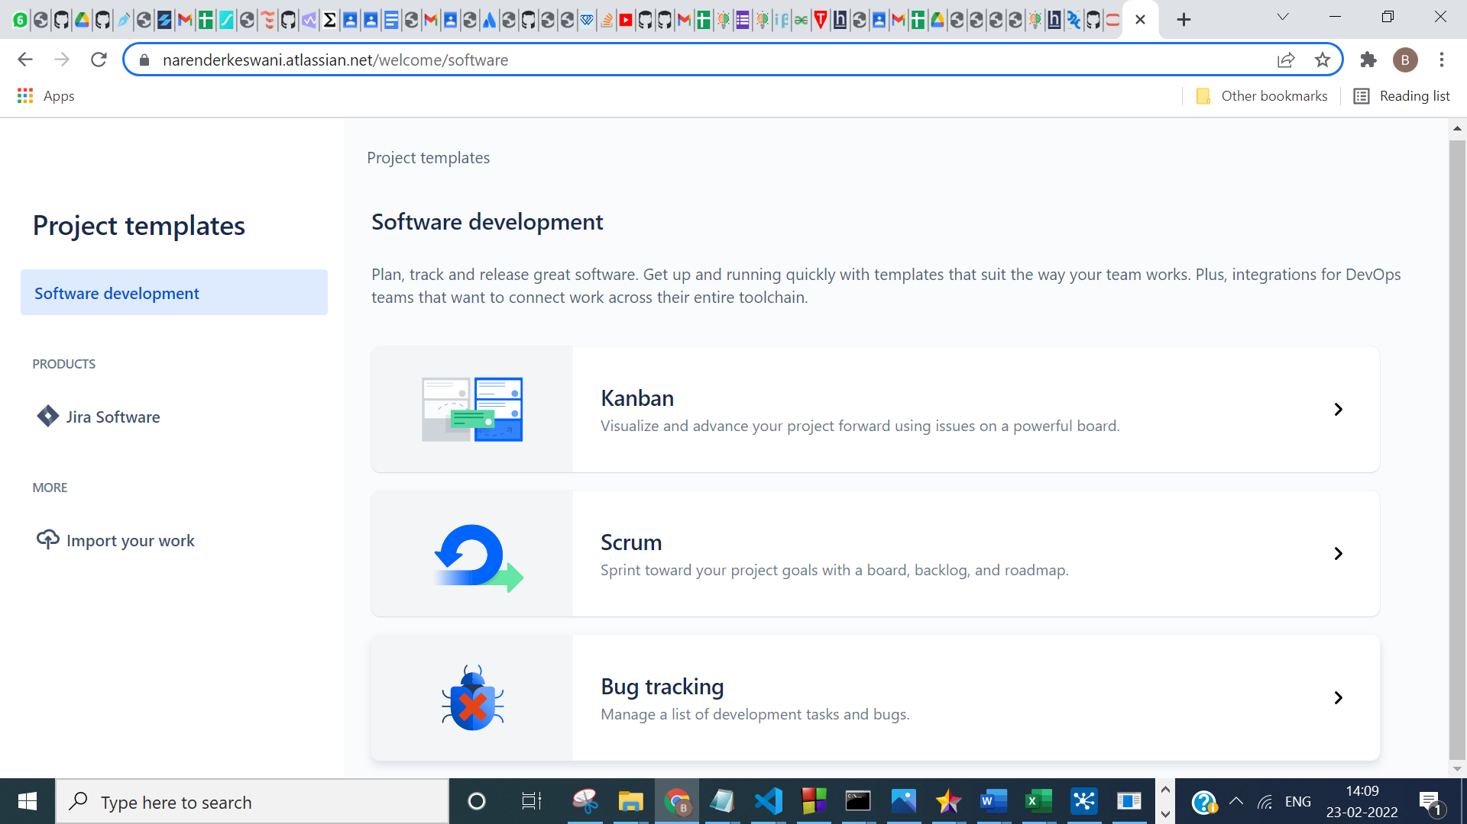

**2: CHOOSE YOUR PROJECT TEMPLATE:**

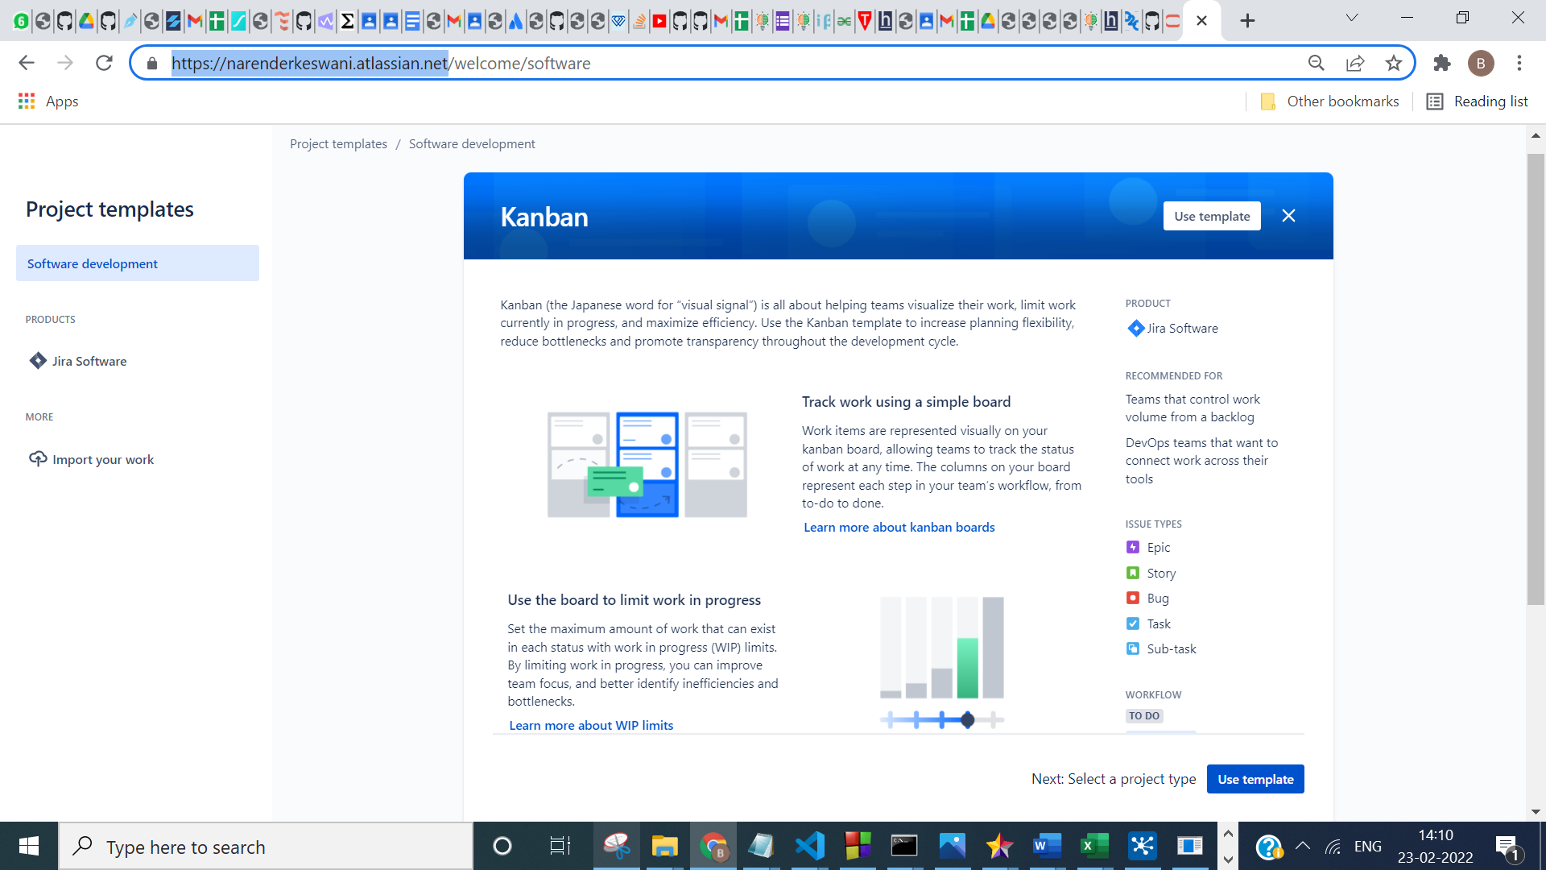

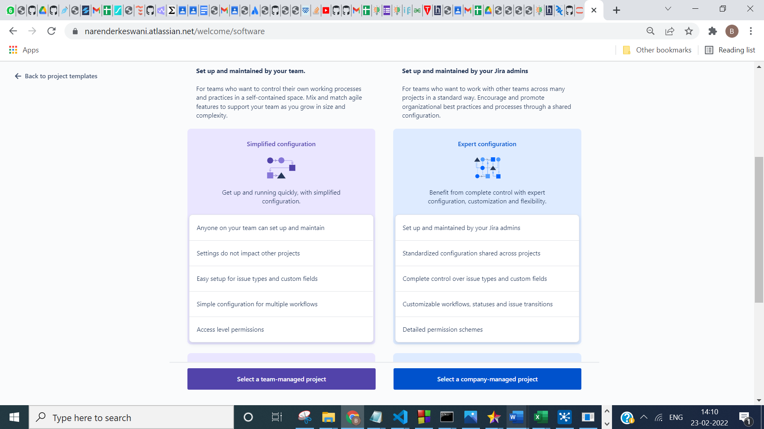

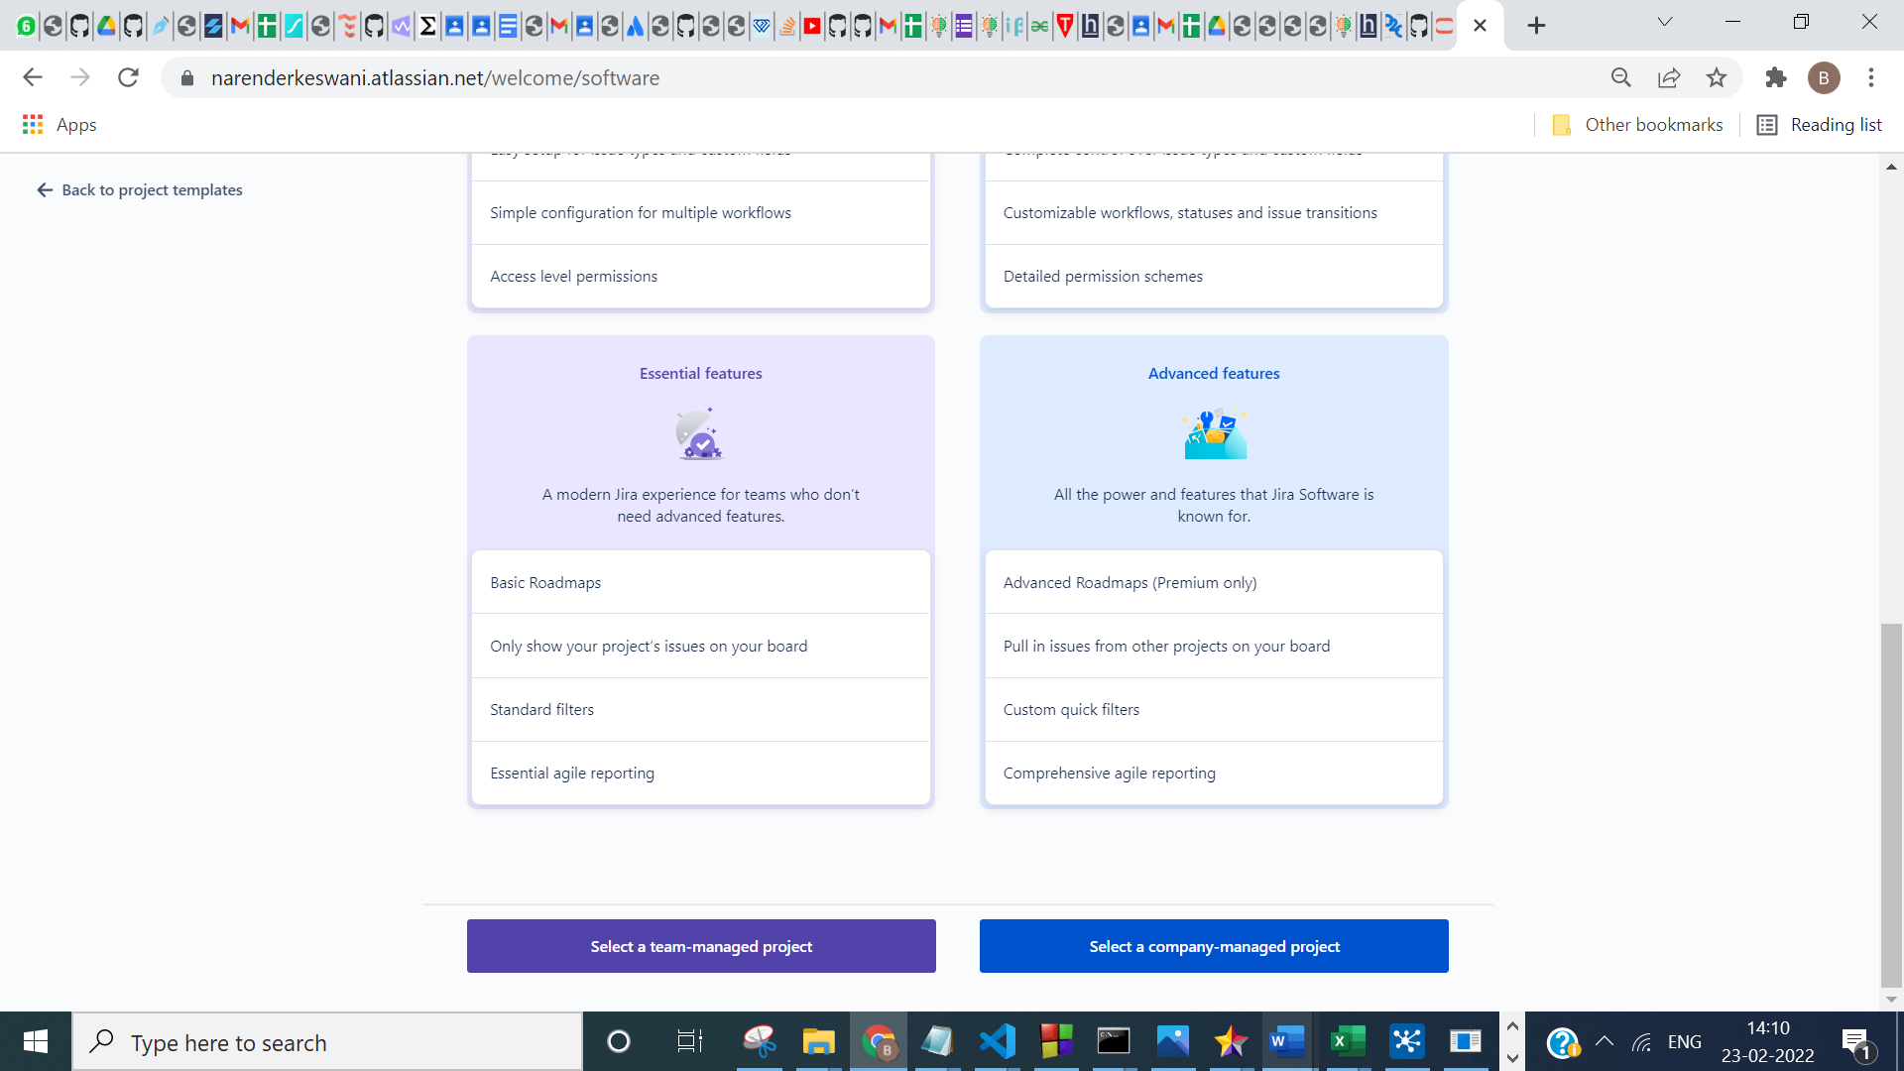

**3: ADD YOUR PROJECT DETAILS**

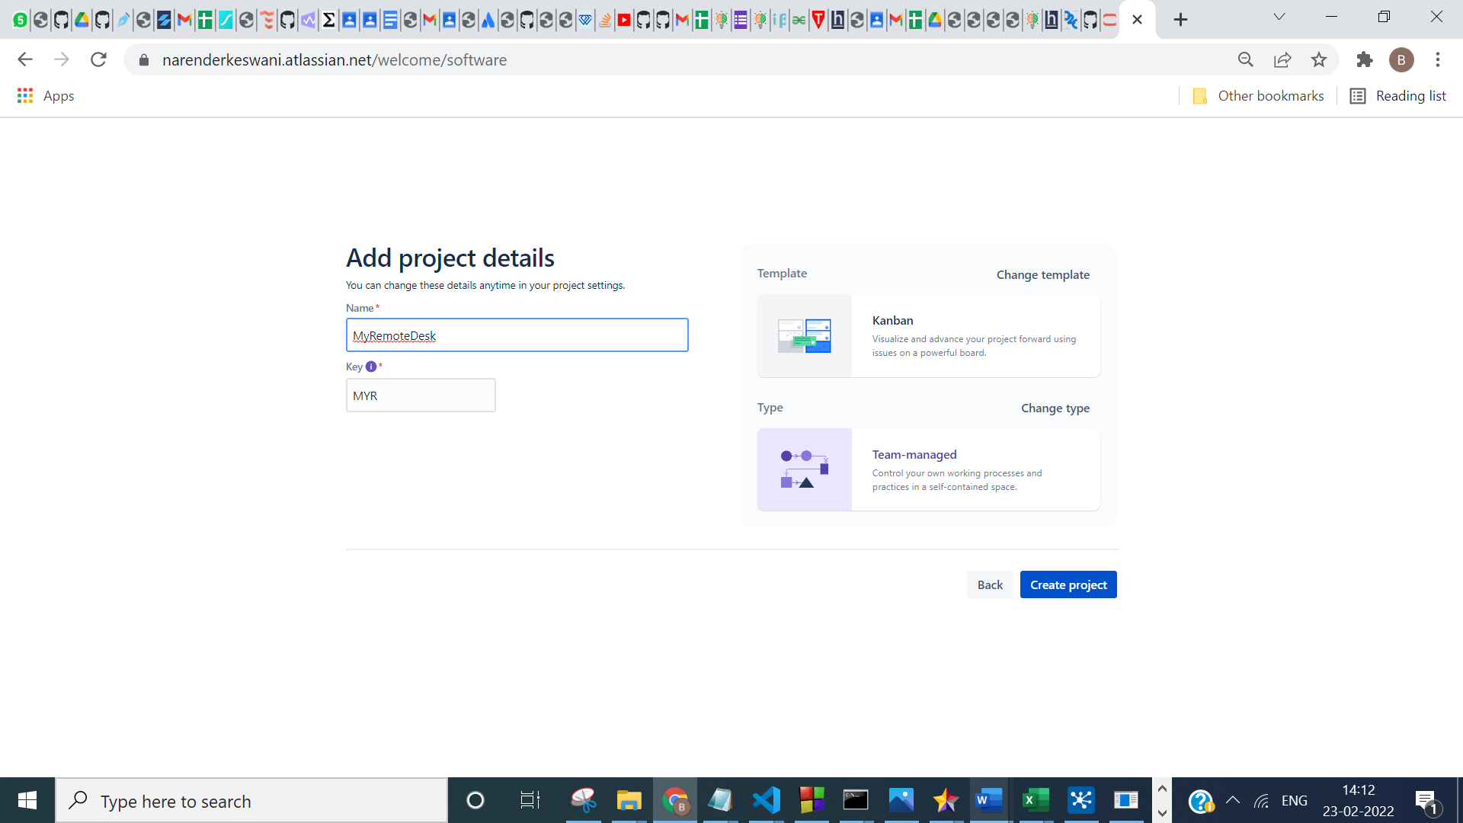

**4: CREATE BOARDS FOR YOUR PROJECT**

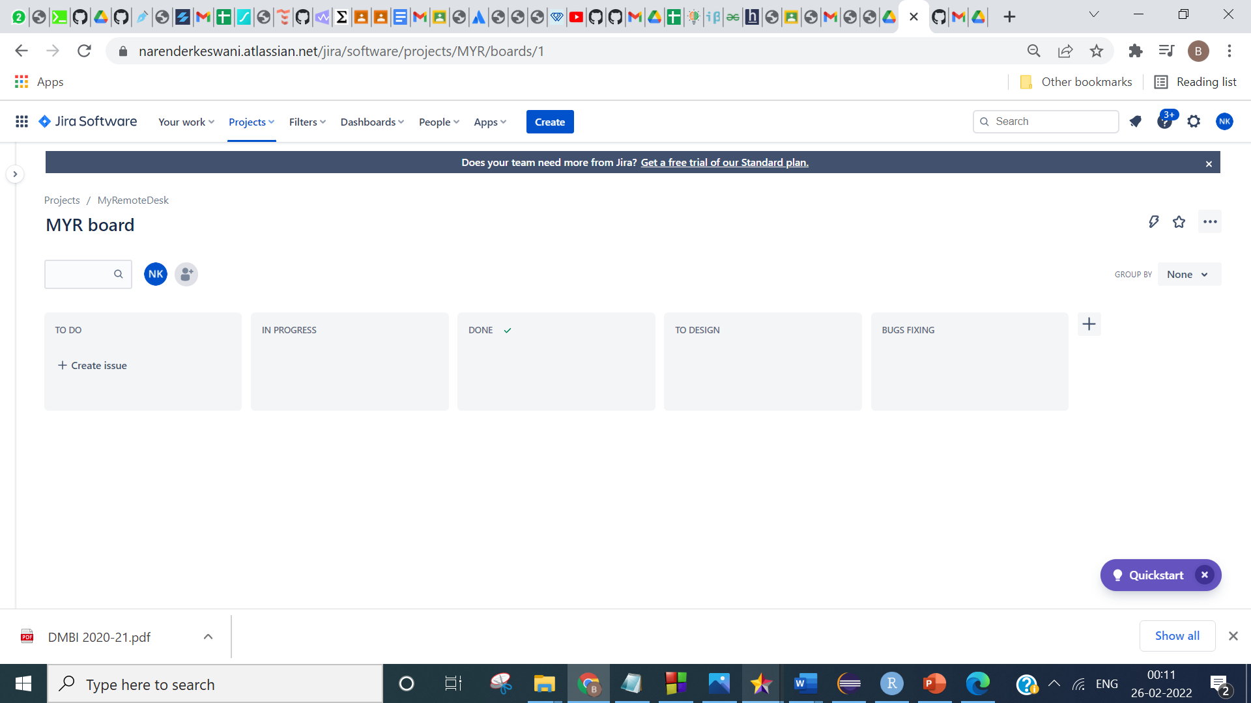

**5: ENABLE THE FEATURES BACKLOG & SPRINT IN THE PROJECT SETTINGS**

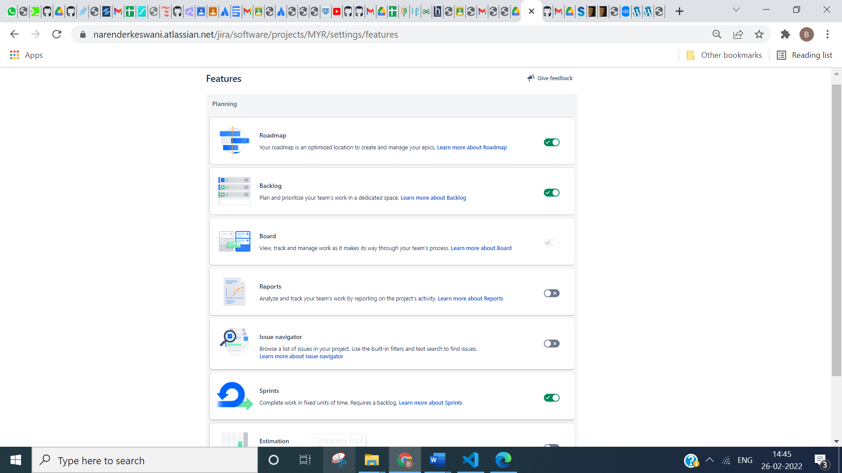

**6: CREATE TASKS & SUB-TASKS OF YOUR PROJECT**

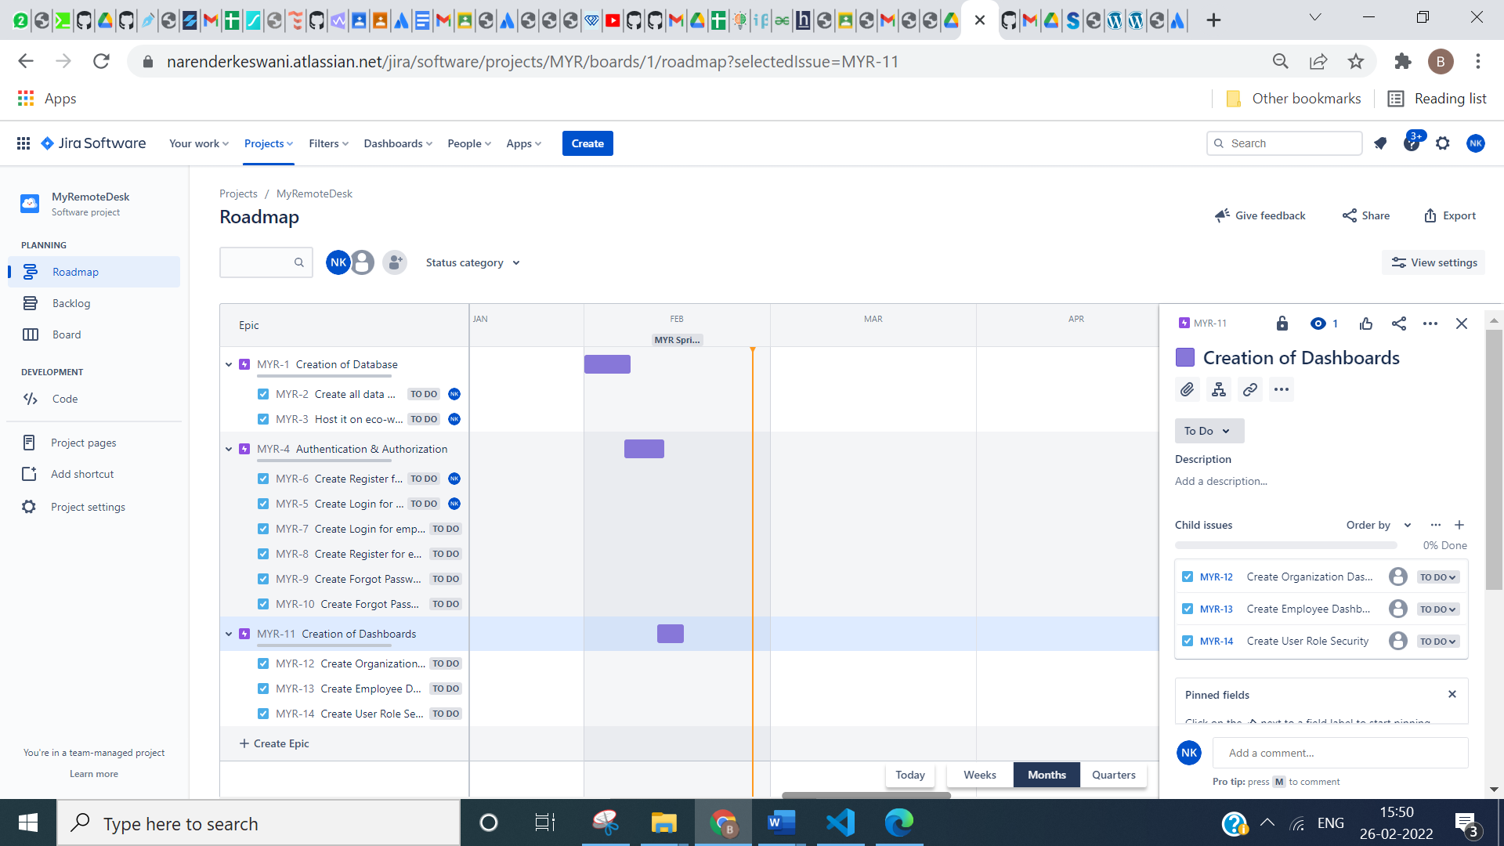

**7: AT THE TIME OF TASK CREATION SPECIFY THE ASSIGNEE NAME , START DATE, DEADLINE DATE, TITLE & DESCRIPTION OF THE TASK**

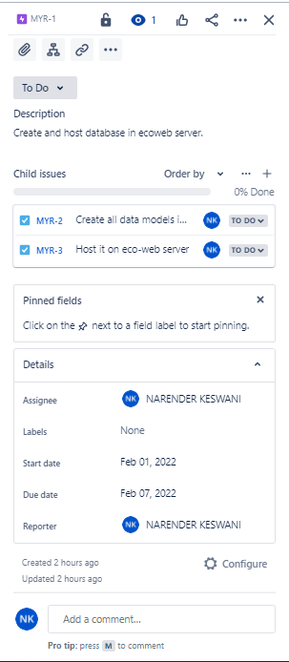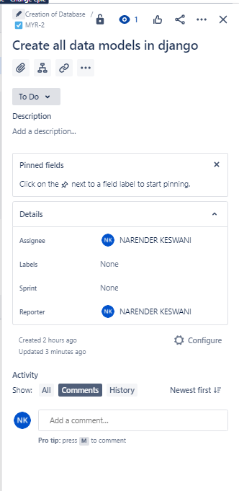

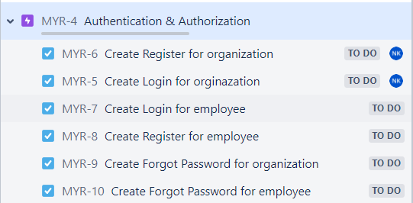

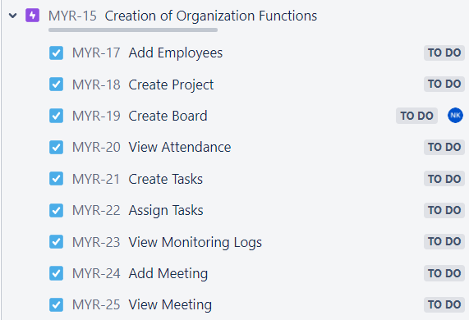

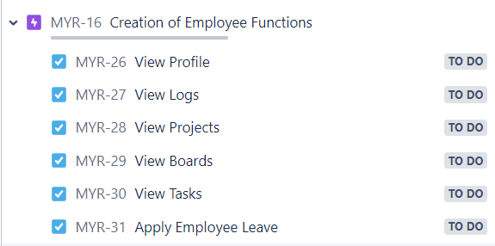

**8: CHECK GANTT CHART OF THE PROJECT:**

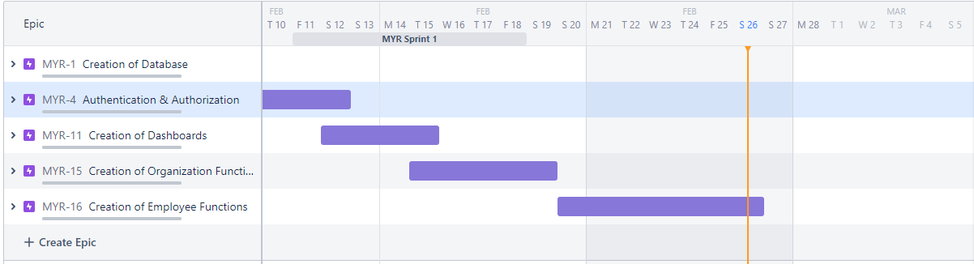

**9: CHECK BACKLOG:**

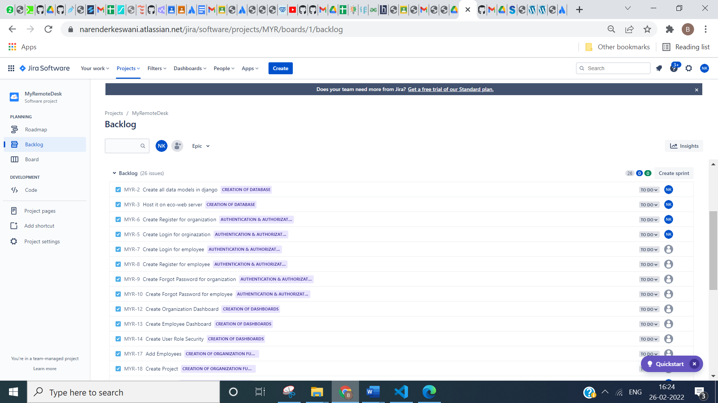

**YOU CAN ALSO FILTER & VIEW:**

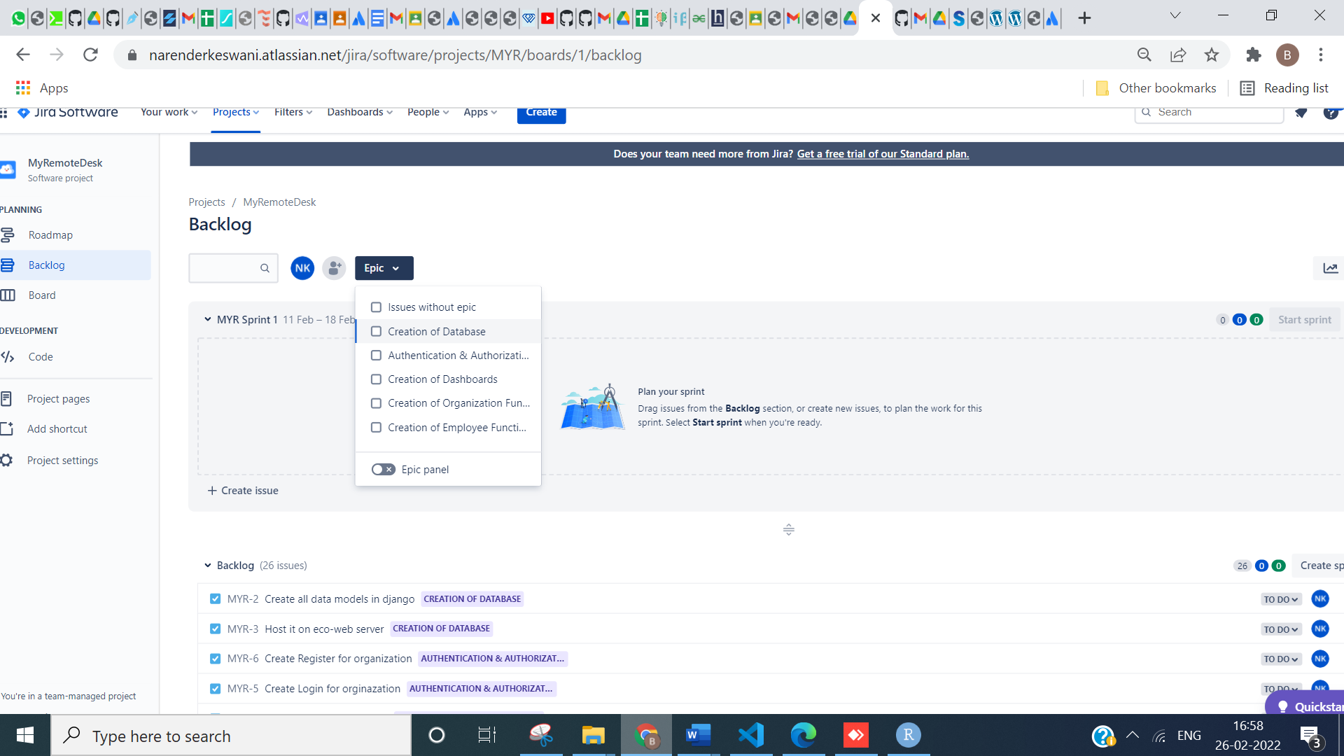

**10: ADD BACKLOGS IN SPRINT:**

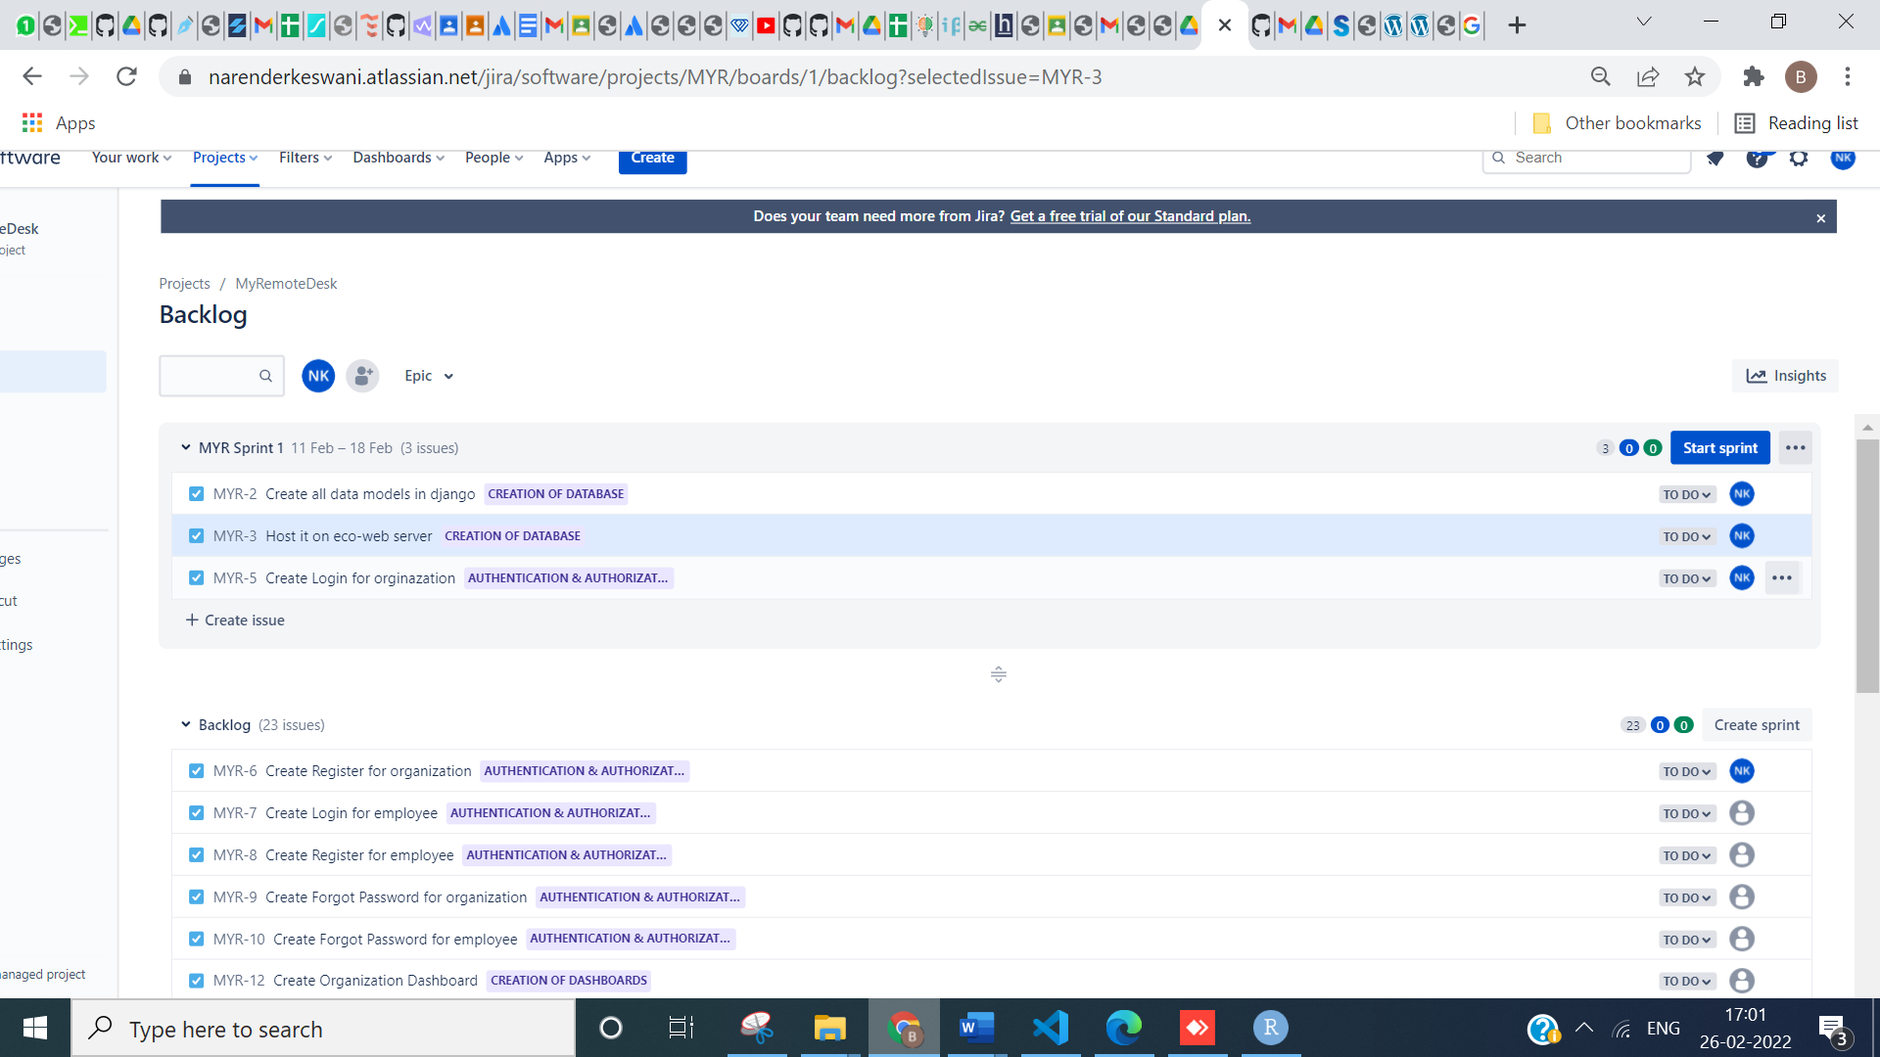

**11: START SPRINT:**

**PROVIDE NAME OF SPRINT, DURATION, START DATE & STOP DATE, ETC**

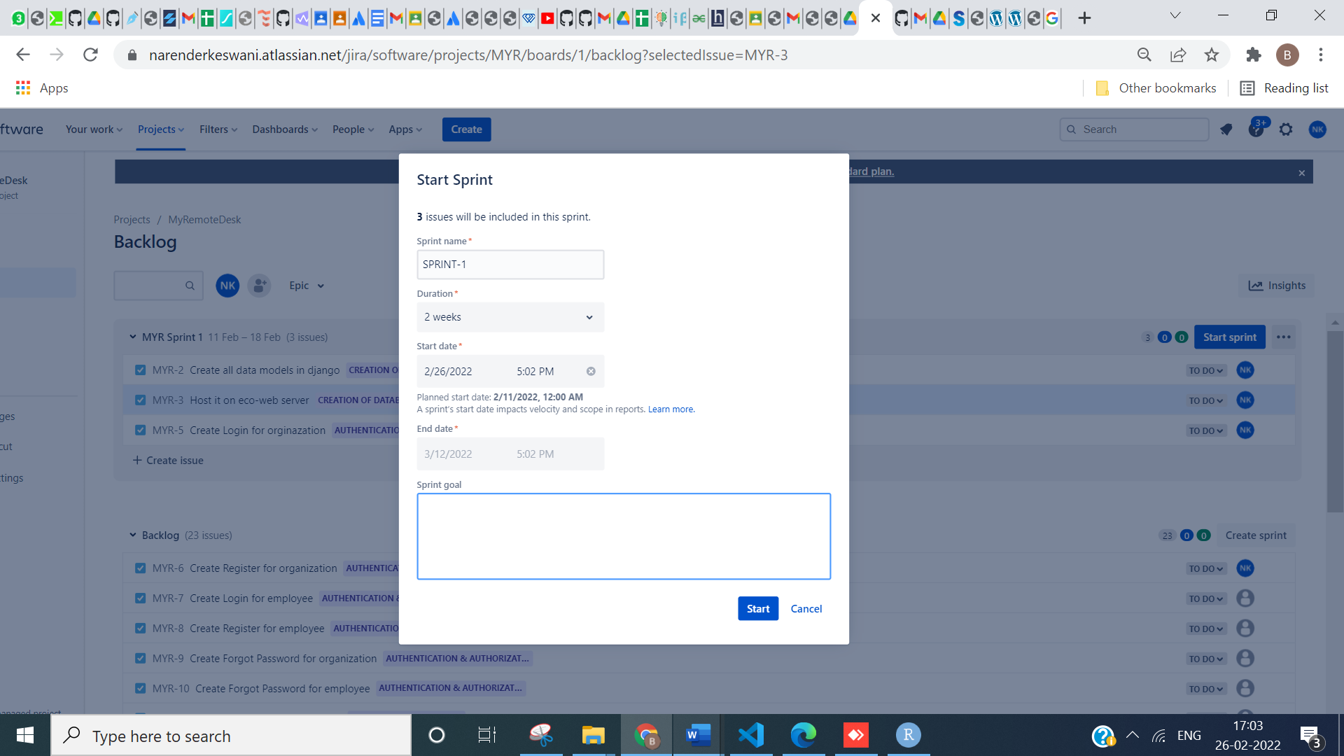

**12: CHECK BOARDS:**

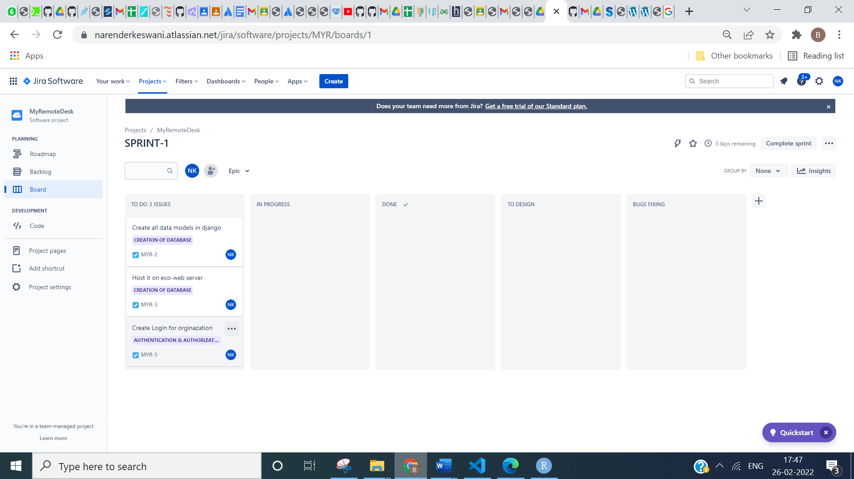

**13:**

**COMMENT YOUR ISSUES:**

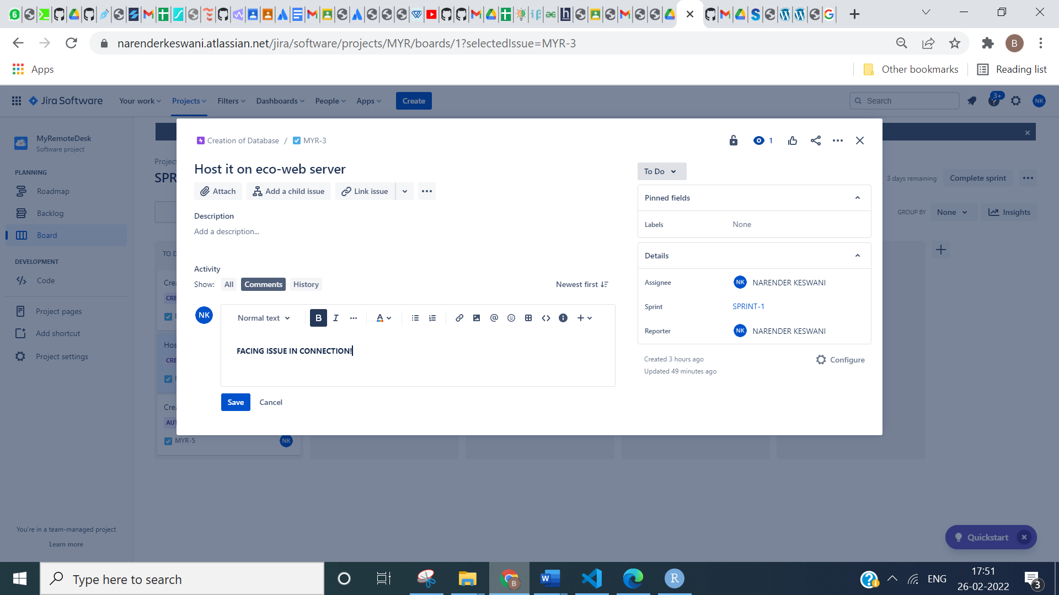

**14: IF WORK IS COMPLETED, THEN MARK IT COMPLETED:**



**15: CHECK SPRINT INSIGHTS:**

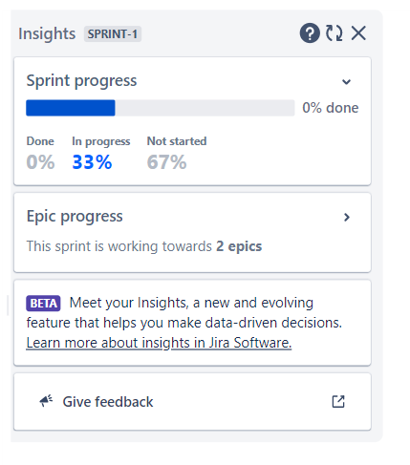

**16: FOR CODE DEVELOPMENT CONNECT TO GITHUB:**

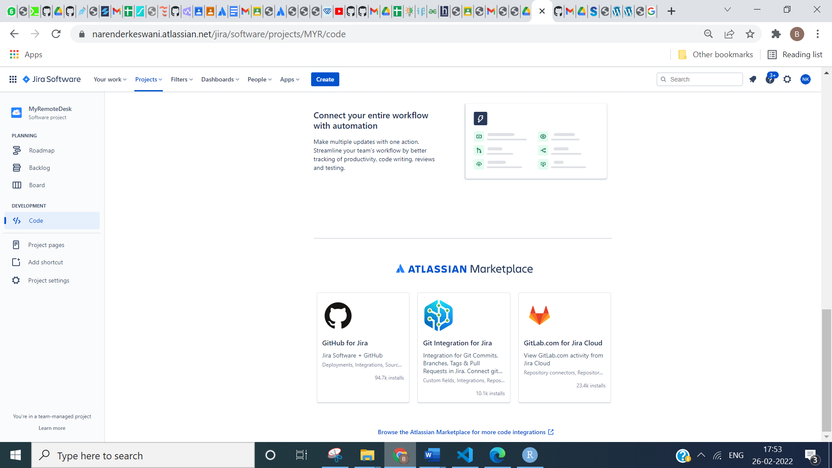

**ADD GITHUB TO JIRA**

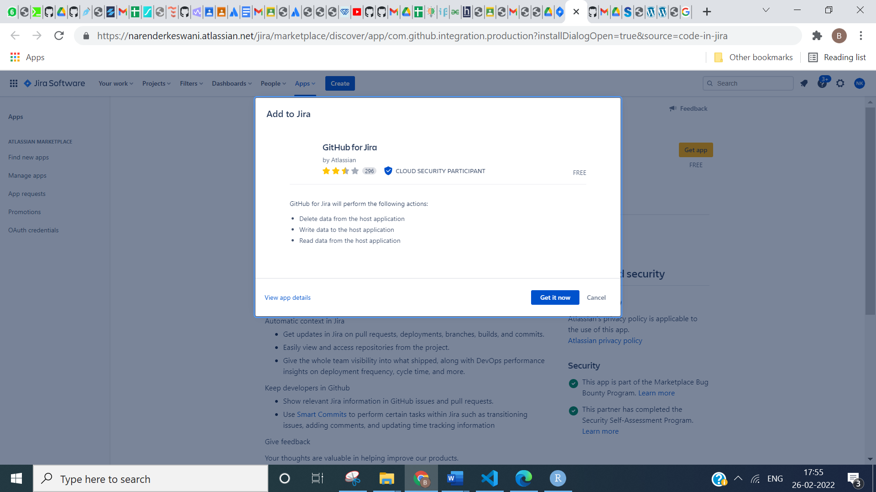

**17: CREATE YOUR OWN CUSTOM DASHBOARD:**

**CLICK ON CREATE DASHBOARD:**

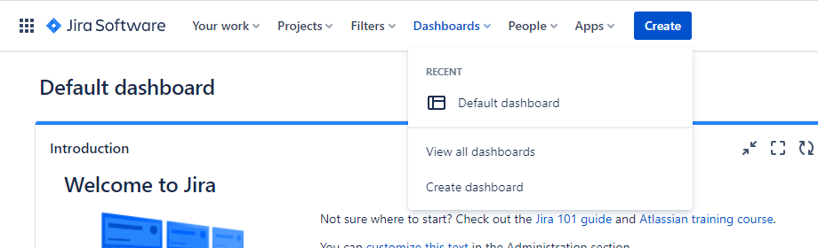

**PROVIDE DETAILS OF DASHBOARD:**

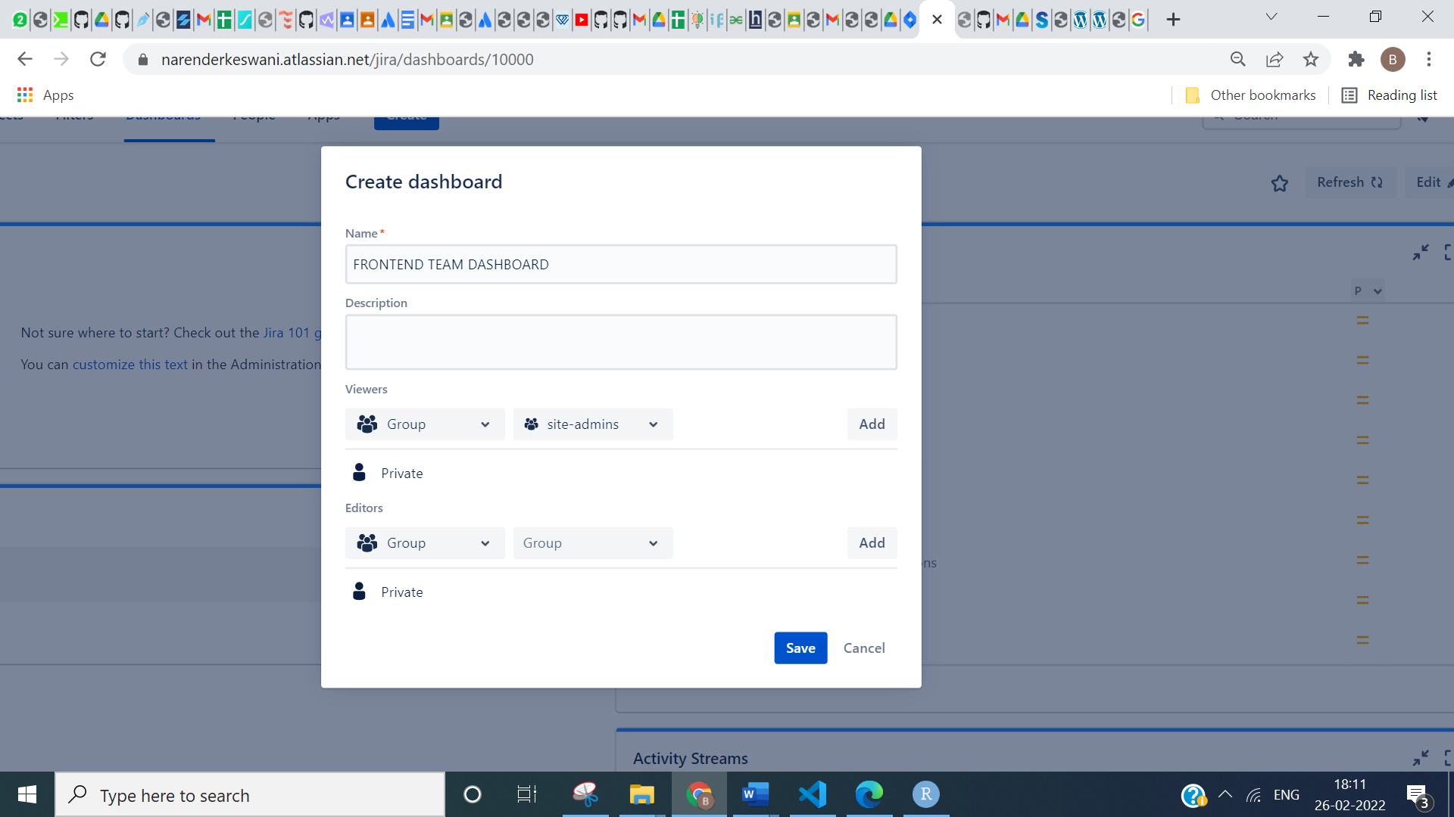

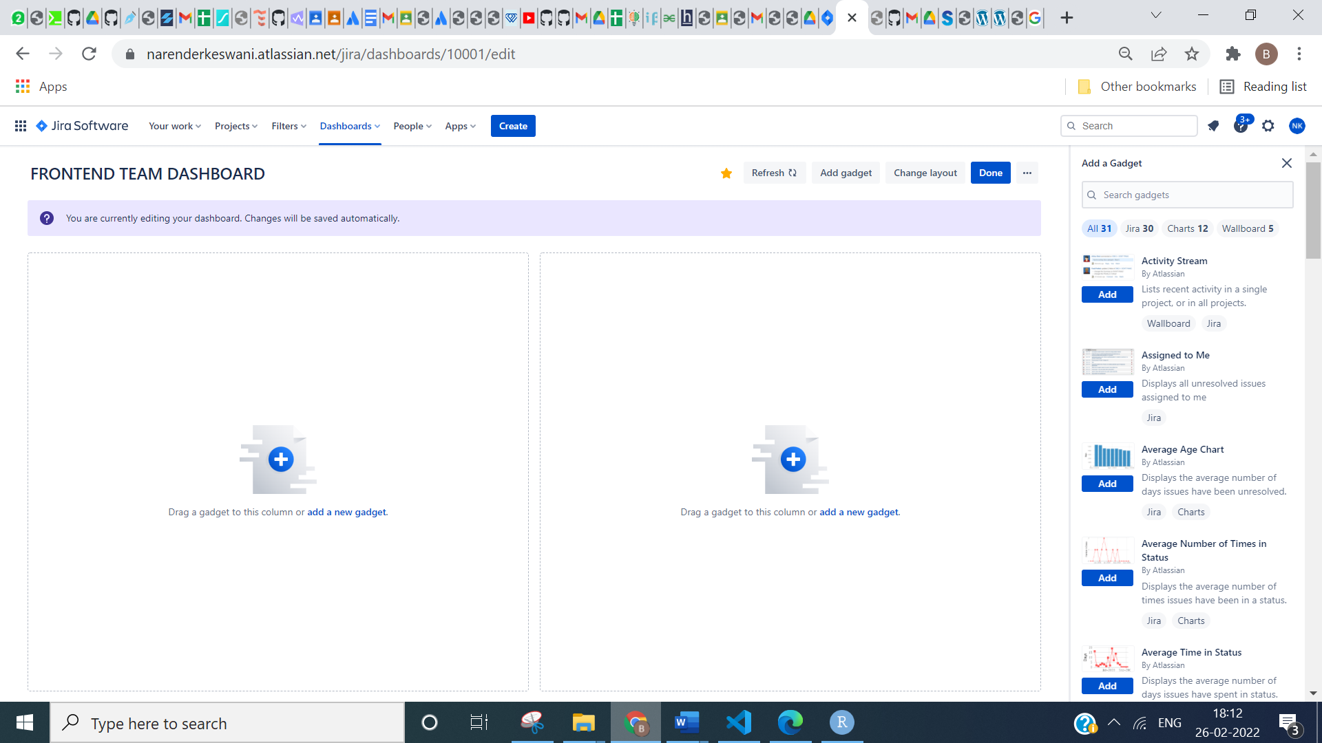

**NOW ADD GADGET ACCORDING TO YOUR REQUIREMENTS:**

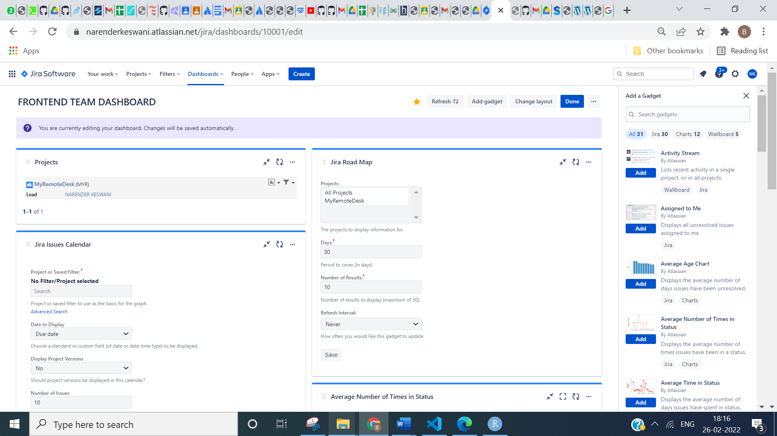

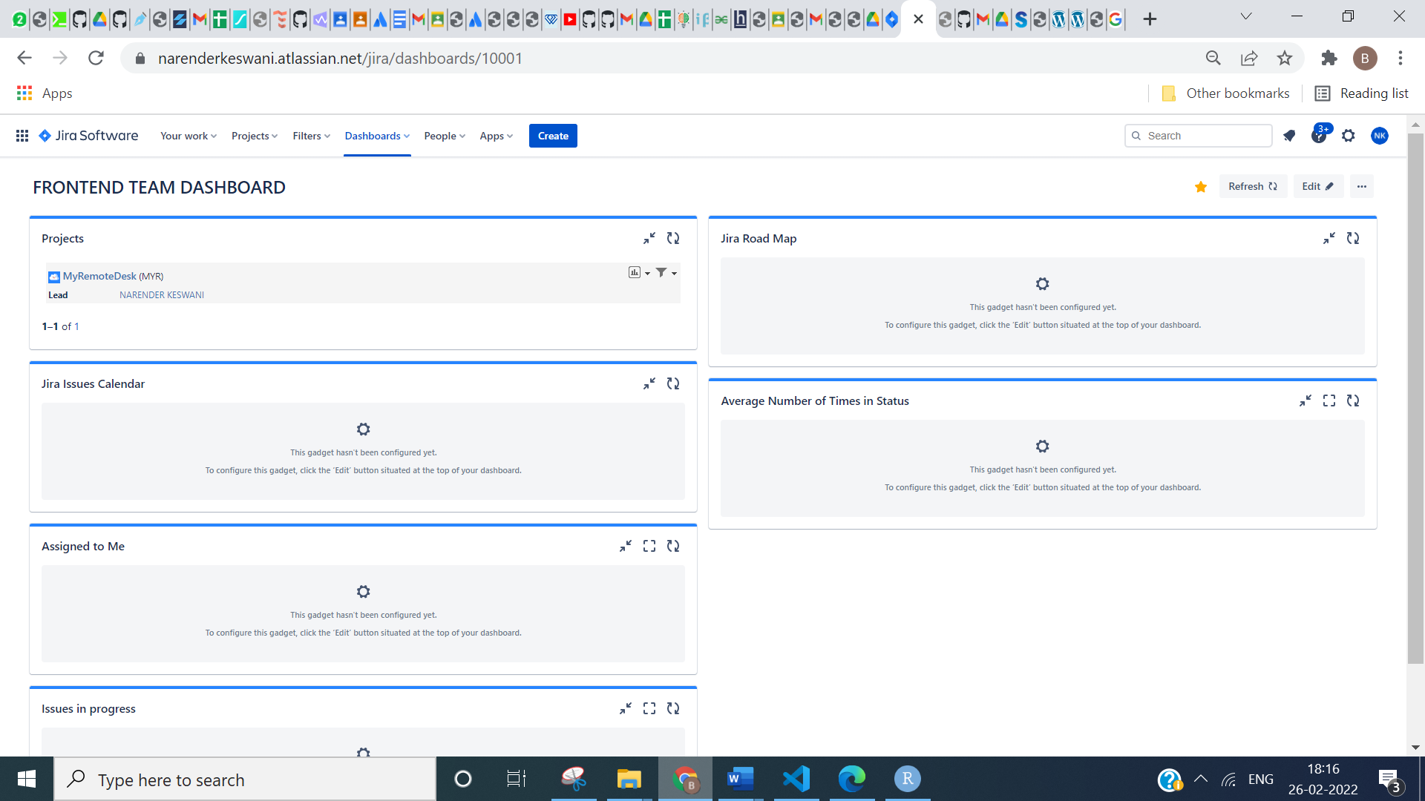

**18. INVITE A TEAMMATE:**

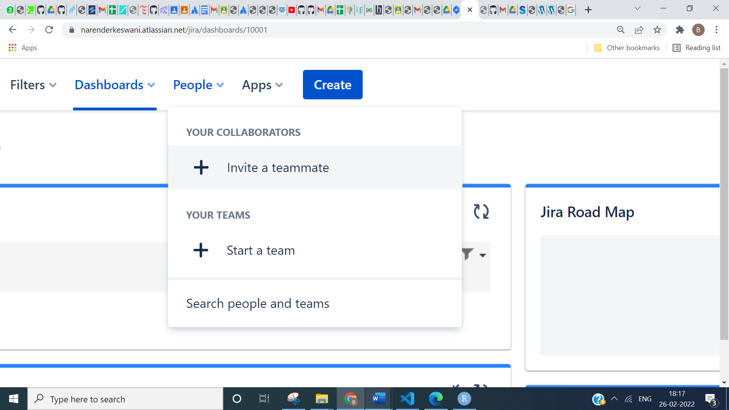

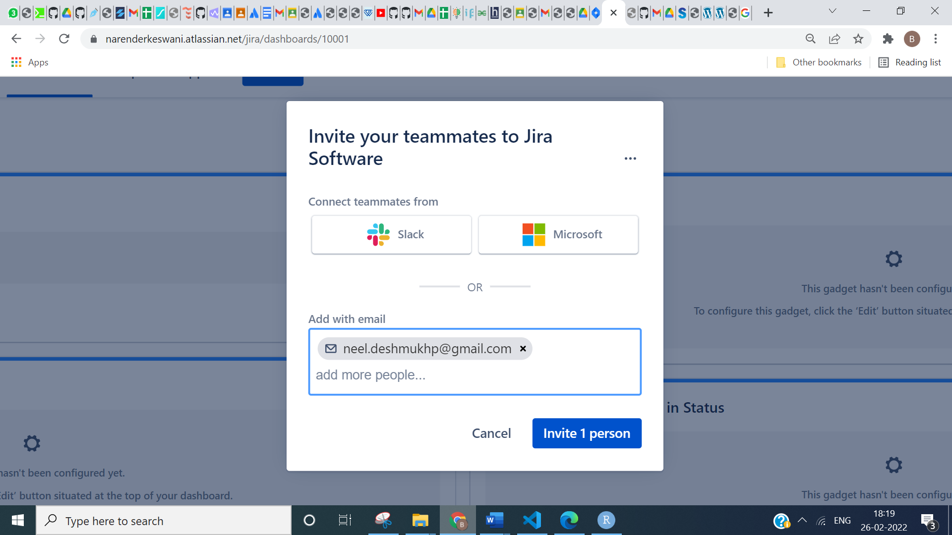

**19. CHECK ALL YOUR PROJECTS:**

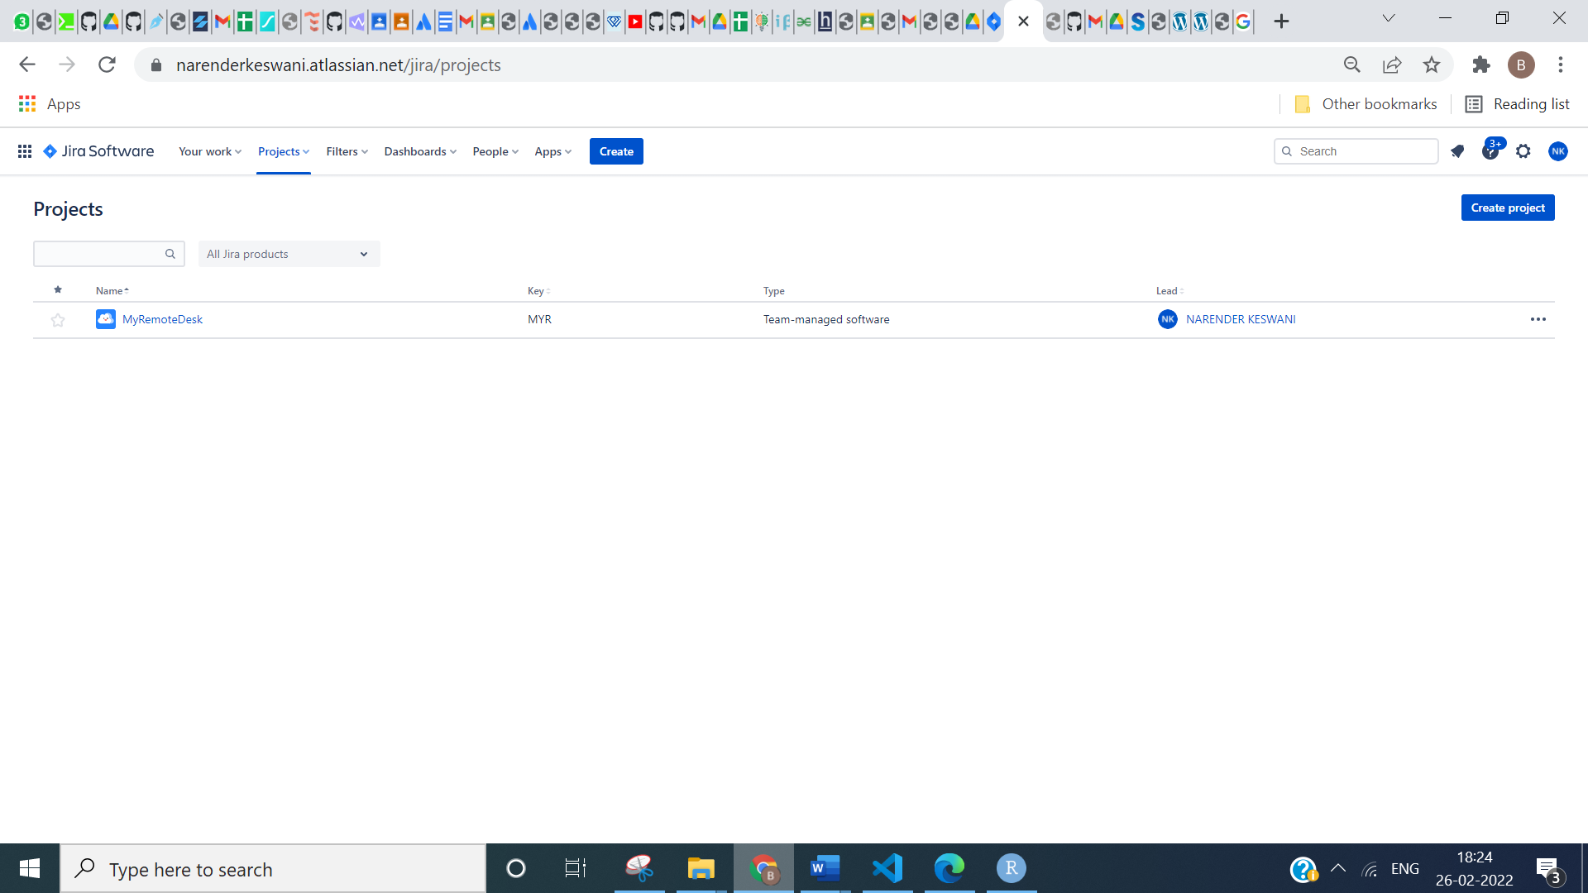

**20. CHECK ROADMAP:**

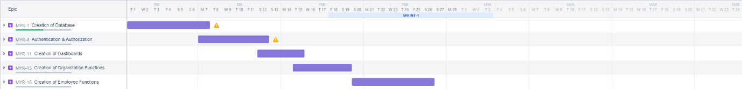

**21. ADD CUSTOM ISSUE TYPE:**

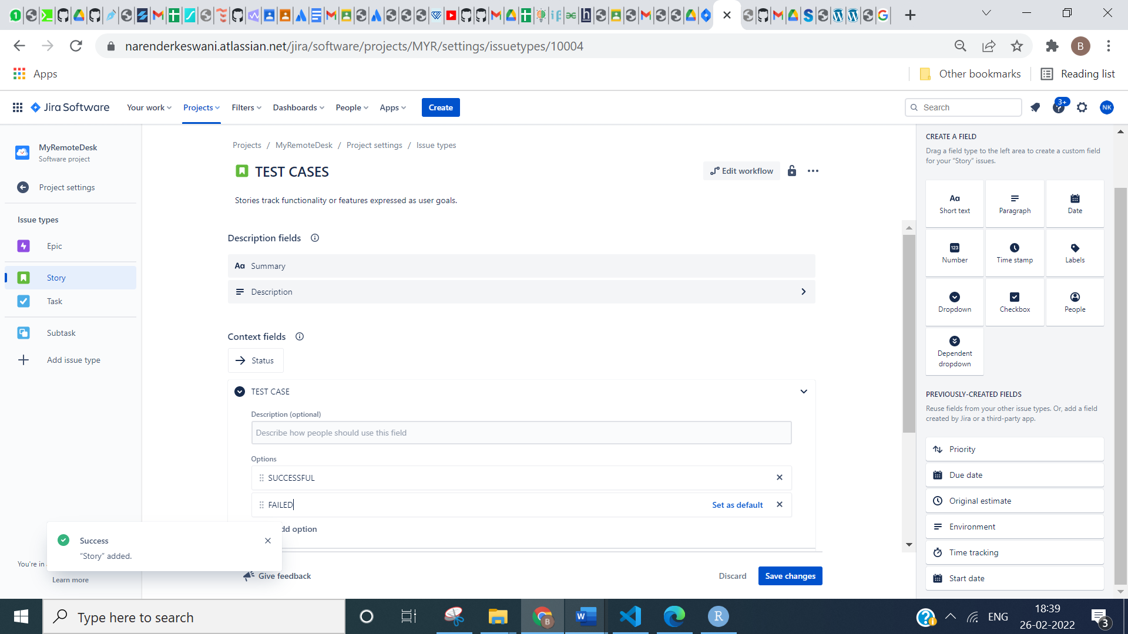

**22. ADD SHORTCUT FOR EASY ACCESS:**

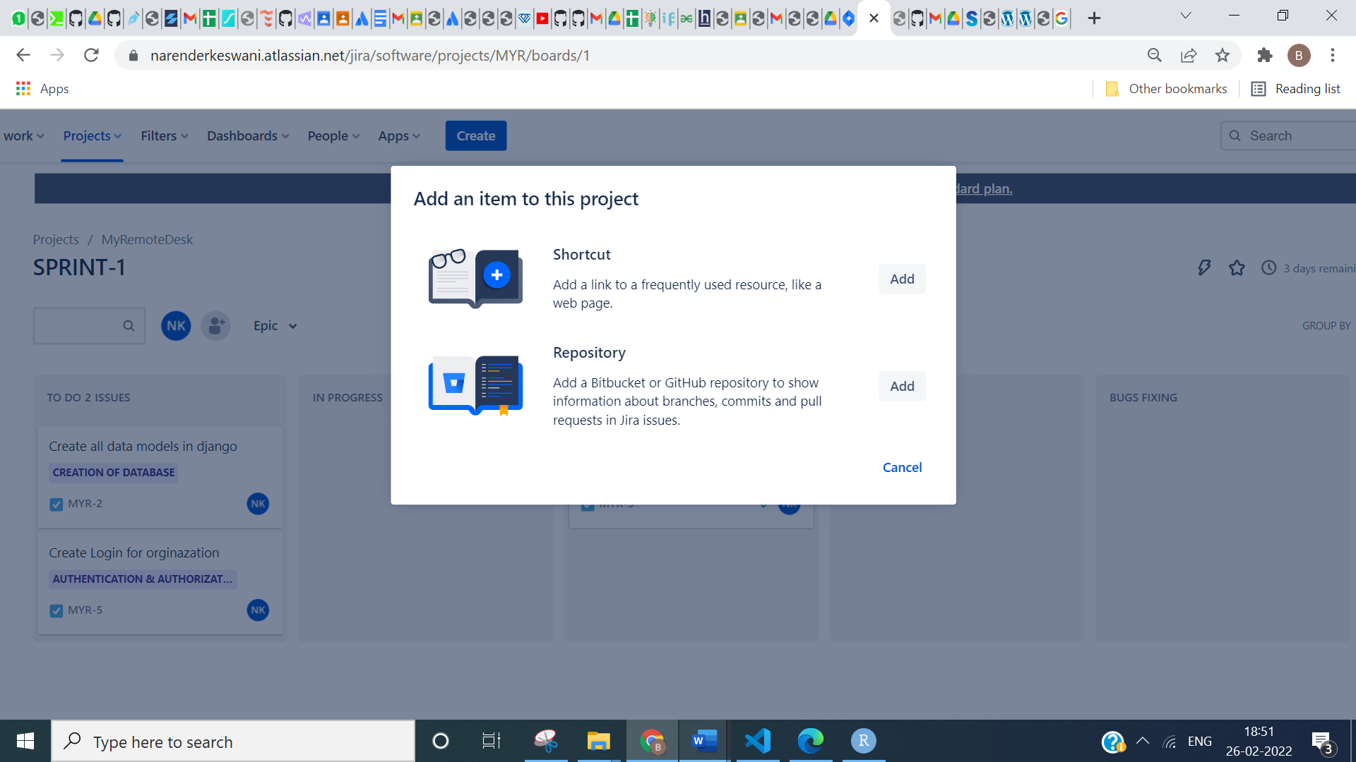

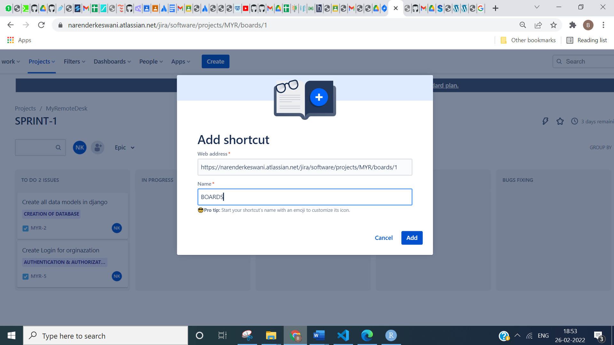

**23. MARK COMPLETE SPRINT IF ALL ISSUES ARE SOLVED:**

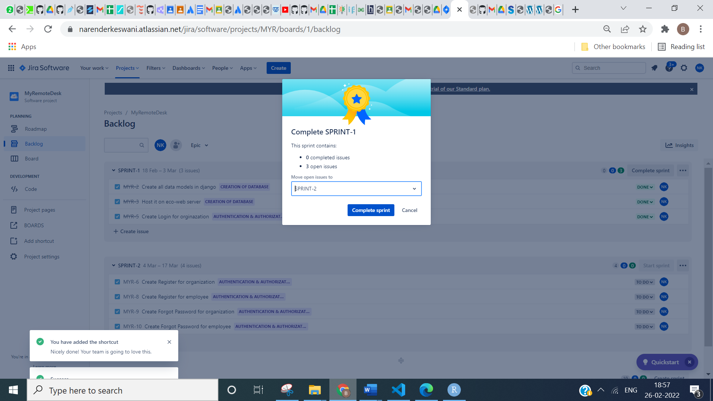

**NOW MOVE ON TO SOLVE NEW ISSUES:**

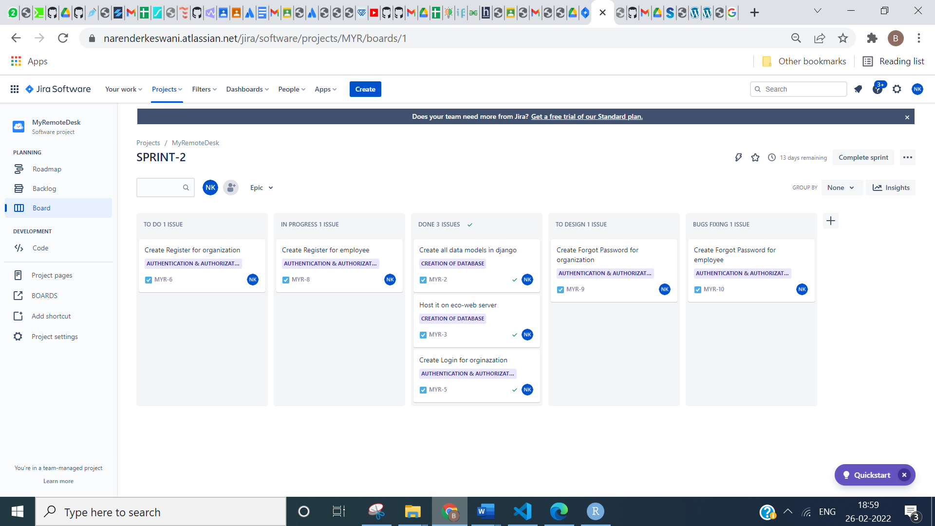

**CONCLUSION:**

* Integration is available in this Jira. That means the issue and project tracking software integrated with several third-parties Software’s.
* Jira is suitable for different types of users like developers, project managers, engineers, non-technical professionals and so on.
* Supports the roadmap requirement.
* Jira enables users to create any kind of issue.
* Jira follows agile methodology.
* Jira helps us to track our project progress.